Function  功能 | Steps  步骤
Domestic Calls  拨打国内电话 | 1. Shanghai landline phone: dial the phone number directly  1. 上海座机：直接拨打座机号码  2. Other provinces landline phone: dial the area code + the phone number  2. 外地座机：拨区号+座机号码  3. Shanghai mobile phone: dial the mobile phone number directly  3. 上海手机：直接拨打手机号码  4. Other provinces mobile phone: dial 0 + the mobile phone number  4. 外地手机：拨0+手机号码
International Calls  拨打国际电话 | Dial 00 + the international area code + the phone number  拨00+国家区号+电话号码
Call back  回拨 | 1. Press the button , see below picture  1. 按键，见下图  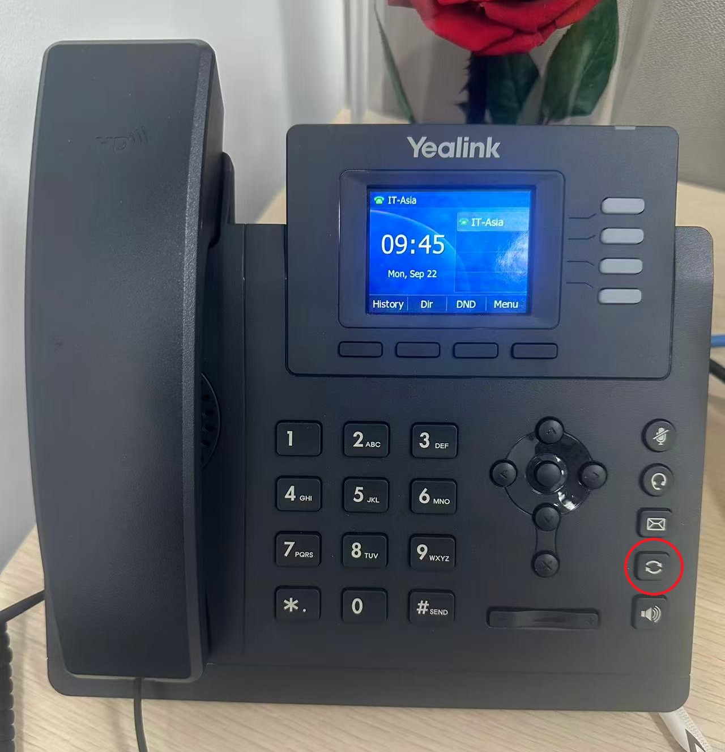  2. Press the button  or  to select the contact or phone number, see below picture  2. 按或键找到需要回拨的联系人或号码，见下图  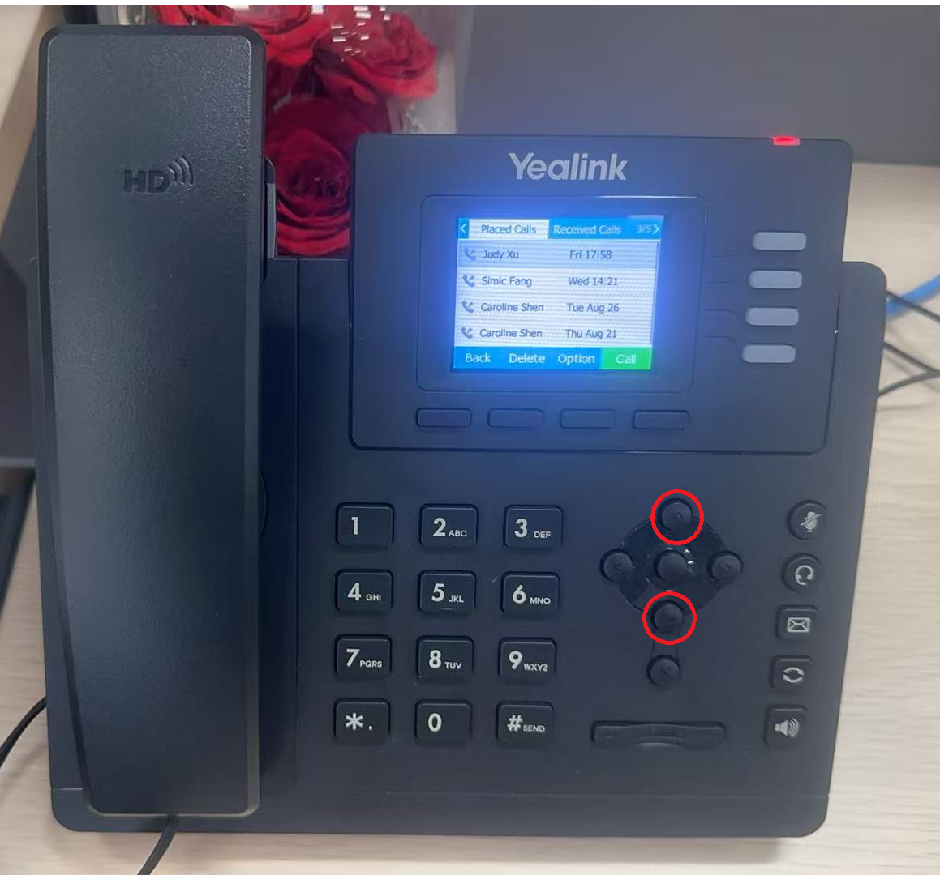  3. Press the “Call” button, see below picture  3. 按“Call“键拨打，见下图  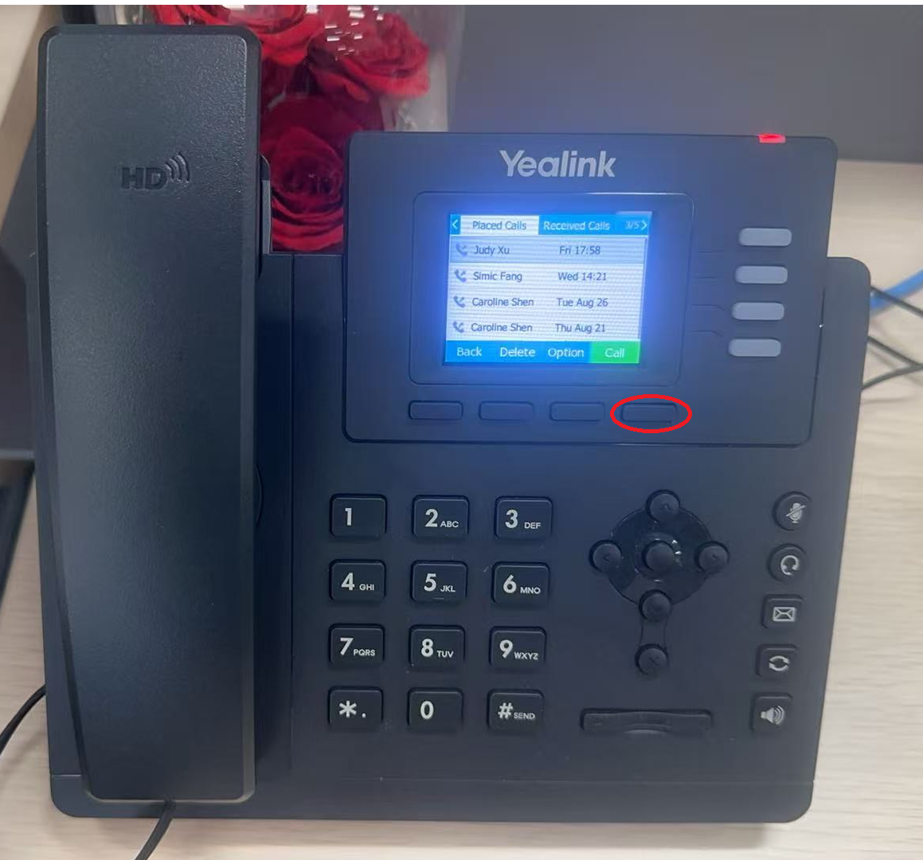
Re-dial  重拨 | Press the button twice, see below picture  按键两次，见下图
Call Transfer  来电转移 | 1. Press the “Trans” button, see below picture  1. 按“Trans“键，见下图  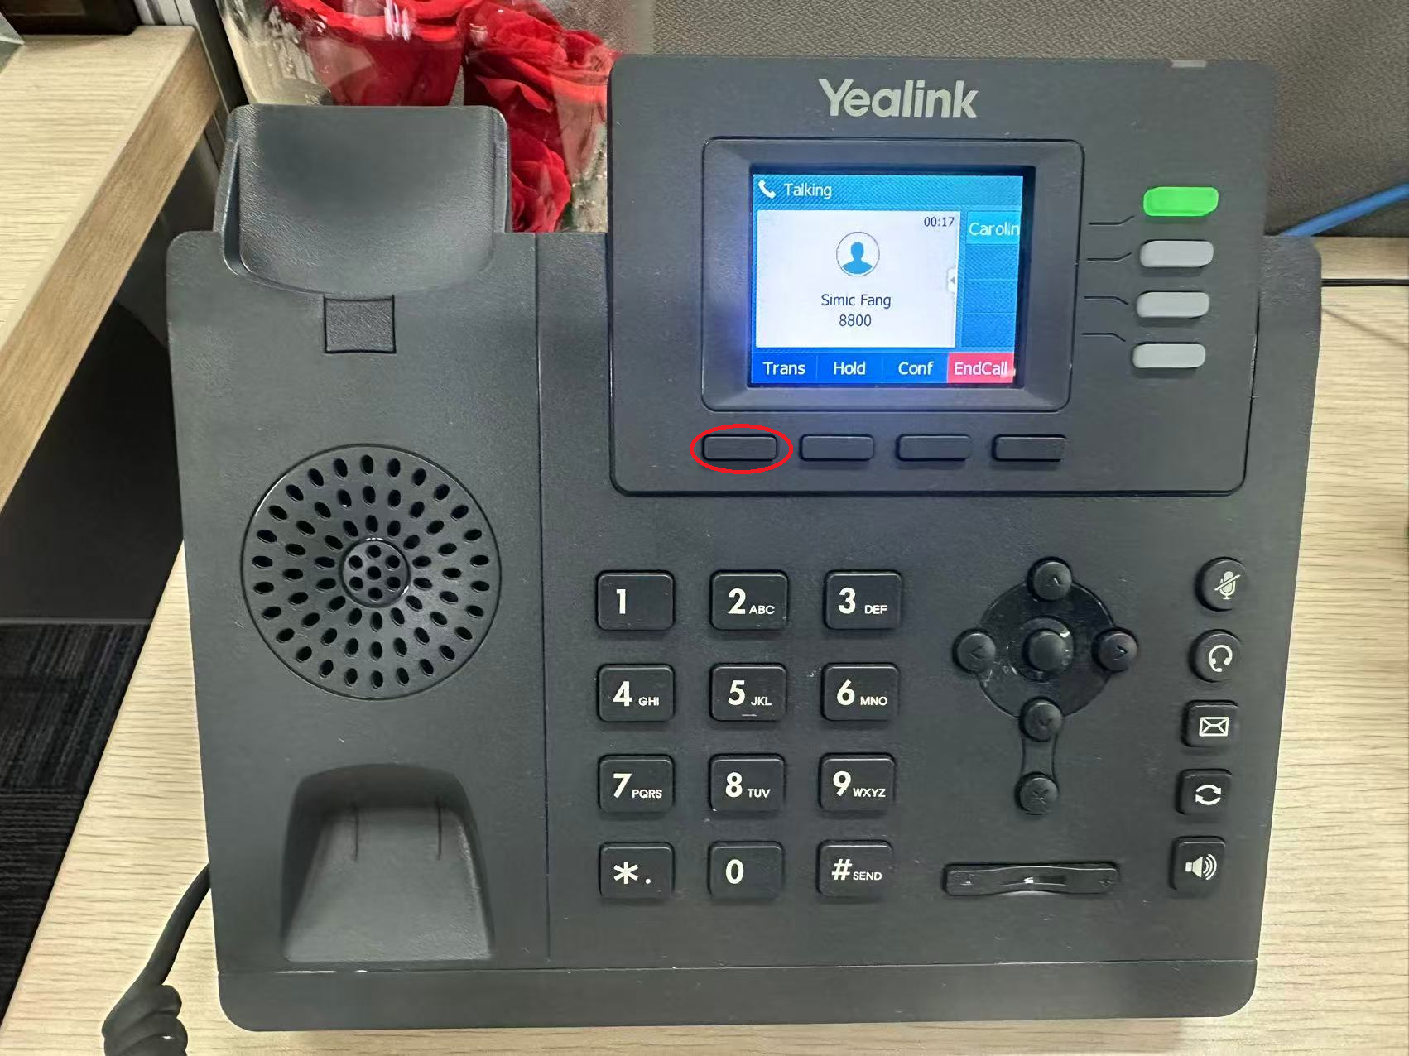  2. Dial the extension number and press the “Call” button, see below picture  2. 按分机号，再按“Call“键转出来电，见下图  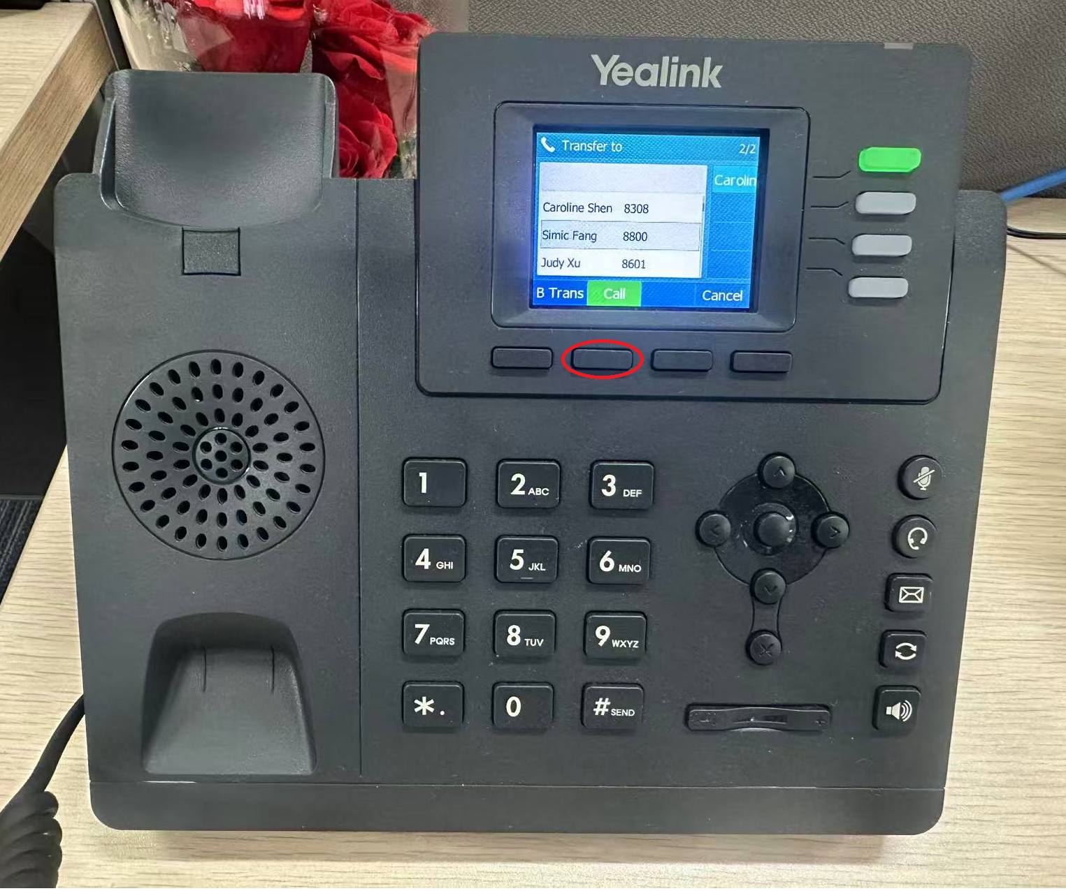
Address Book  通讯录 | 1. Press the “Dir” button, see below picture  1. 按“Dir“键，见下图  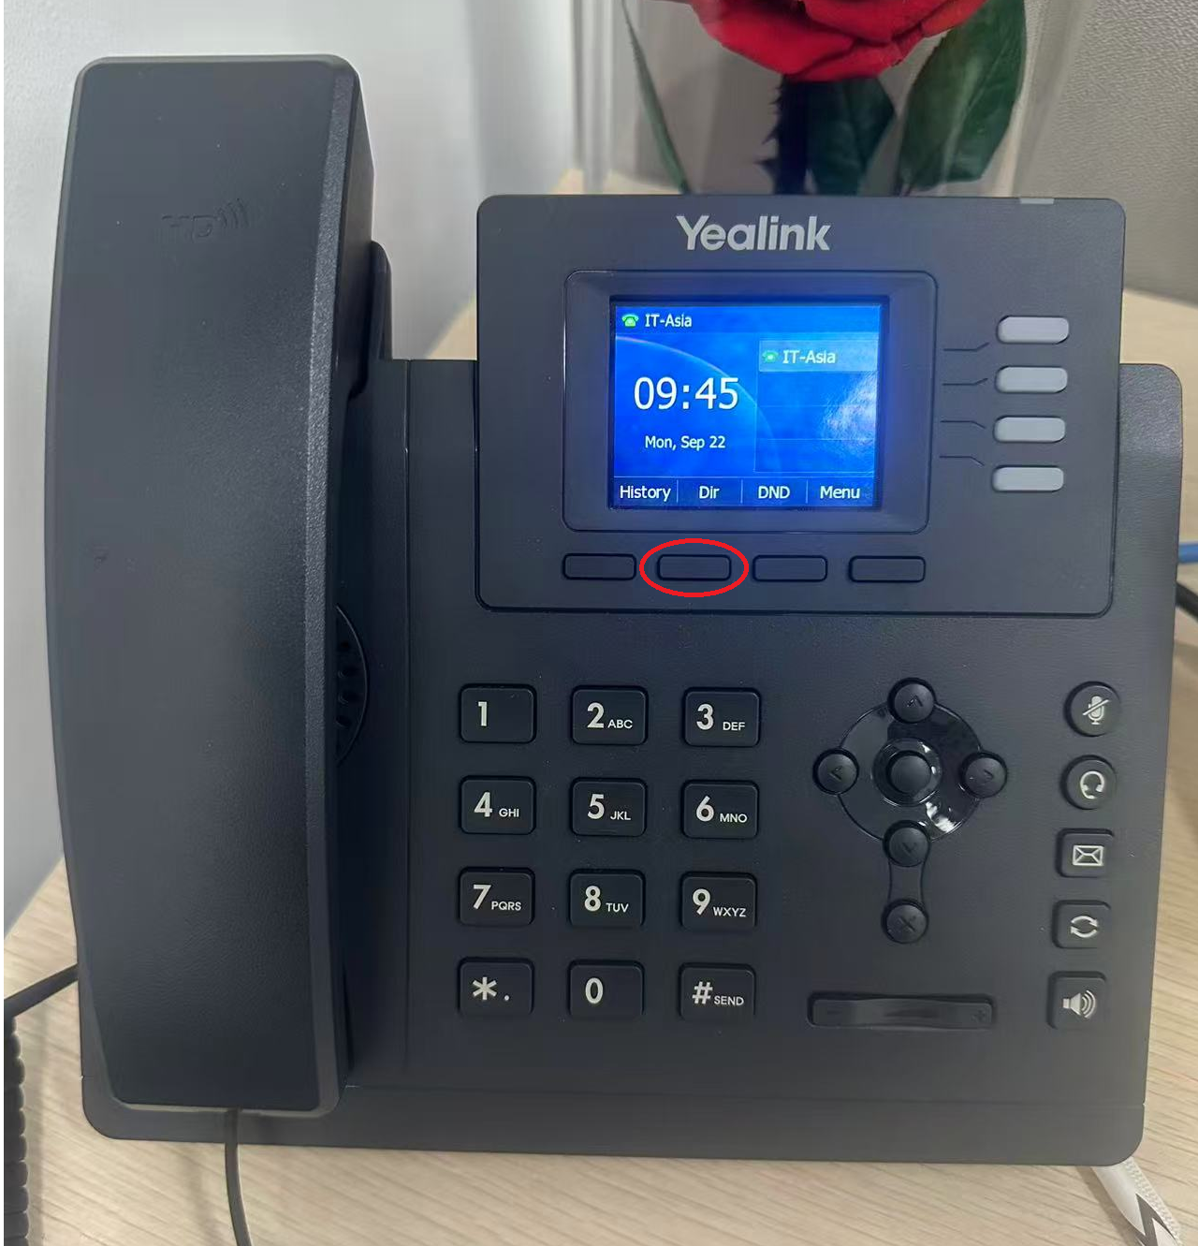  2. Press the “Search” button, see below picture  2. 按“Search“键，见下图  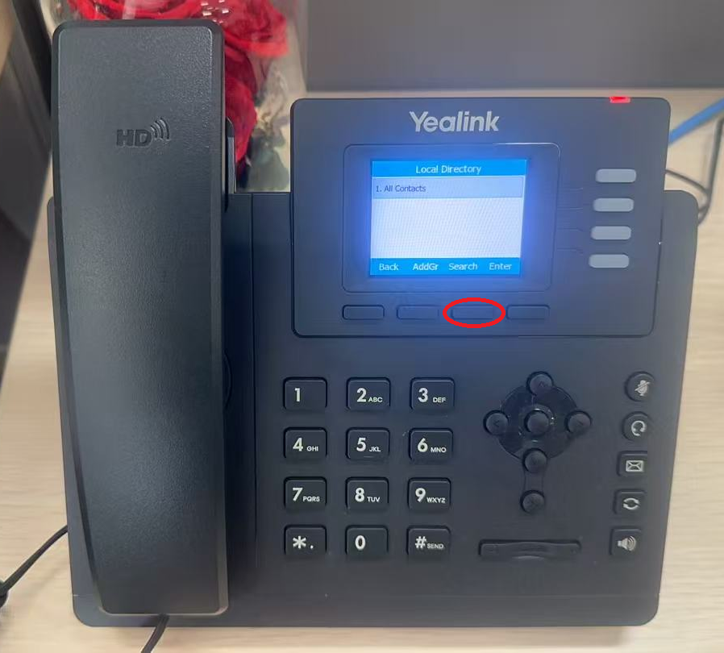  3. Press the number buttons to search the contact, see below picture  3. 按字母对应的数字键，找到联系人，见下图  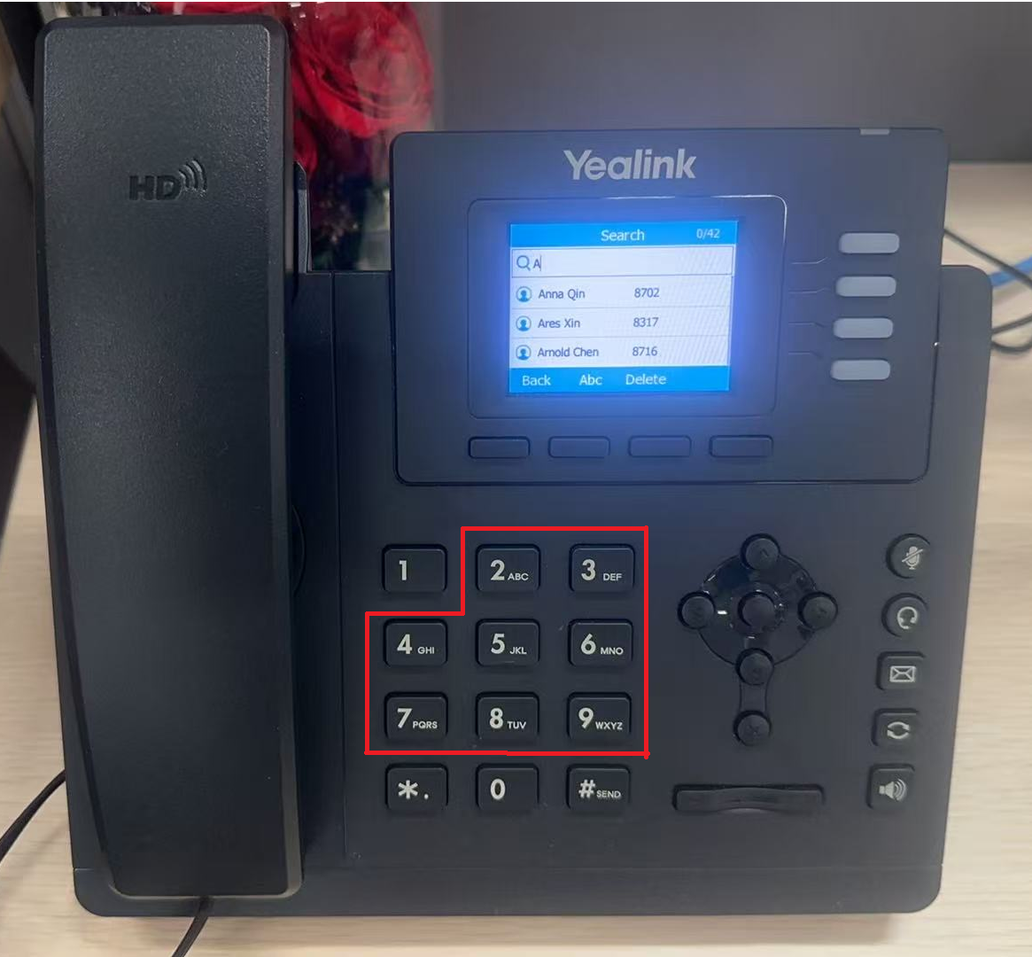  4. Press the button or to select the contact and then press the “Call” button, see below picture  4. 按或键选择联系人，可按“Call“键直接拨打，见下图  